Why Shaped By God Together?
Last year we formally began the Shaped By God Together process in the diocese, to discern the way forward for us as we seek to work with God in building His kingdom here in Leicestershire.
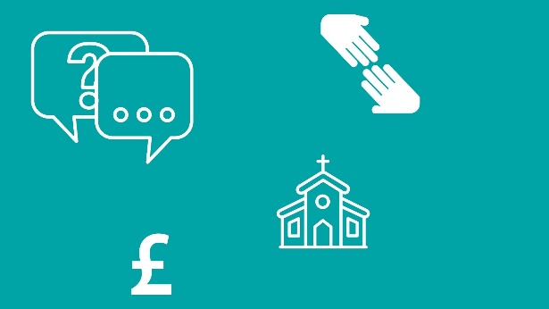
You may have already joined in and taken part in one of the conversations we’ve had about ministry, buildings, and finance, perhaps you sent in a story about your faith experiences of lockdown, maybe you’ve been at Diocesan or Deanery Synod meetings, or watched our videos or read articles on our website or in Diomail and you may therefore be aware of the different stages of this process o discernment which will come together at Diocesan Synod in October 2021.
For others this may be the first time you are noticing this whole process. We know not everyone has been able to access our material, or had the energy to give it much attention. That is understandable – and we know how hard it has been for our communities to stay together and talk about things when physical gatherings have not been allowed. We’ve tried to be as accessible as we can, but we know that we could always do things better.
So it’s worth reminding ourselves, and stating clearly why we’re doing this... it’s so easy to get caught up in detail of the process and we forget why it’s important.
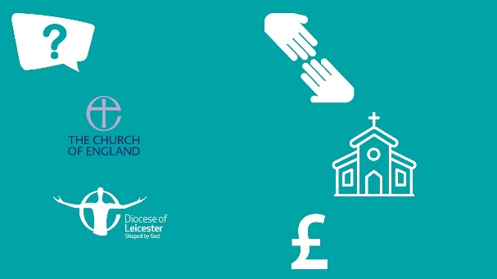
We are undergoing this process because we’ve known for some time (both nationally in the Church of England, and in our diocese) that our ways of doing and supporting mission and ministry, our use of our buildings, and our financial models are no longer suited if we want to be a missional church which seeks to share the love of God in word and deed, through presence and proclamation.
In recent years we have seen many glimpses of God’s glory and have know great joys. We know that all of the Christian communities across our diocese have worked hard to share God’s love faithfully. We’ve had much to celebrate and we’ve also known sorrows, stress and anxiety.
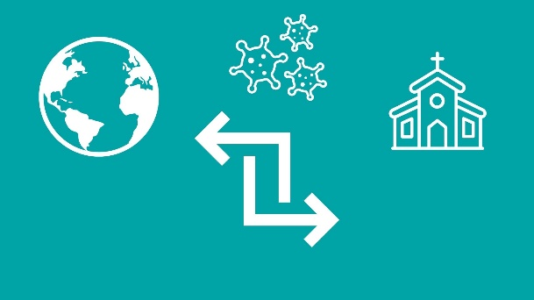
Here’s the thing: The world is changing and church needs to change too. This was true before Covid, but the current pandemic has brought things into even sharper focus. Prior to the outbreak, Bishop’s Council had started talking about a process to develop a framework to reshape the diocese by 2026, but the implications of the pandemic have meant that the process has needed to be accelerated.
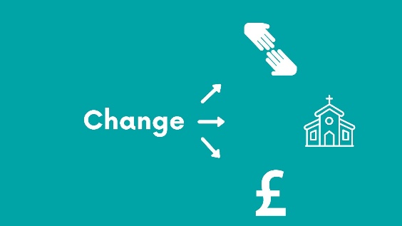
Put simply, if we’re to be true to our vision of “The Kingdom of God”, and our desire to equip every church or fresh expression, worshipping community, and Christian to live out their “everyday faith”, our inherited models and frameworks for “doing” and “being” church will have to change …

The ways we have been operating are both unsustainable (with an ever increasing gap between income and expenditure) and inadequate (reaching the 93% of people in Britain who don’t have regular meaningful contact with a church or Christian community will require new adventures in imagination and innovation).
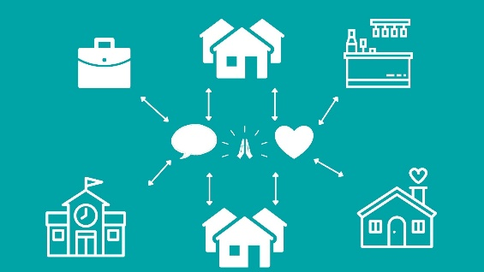
That’s why we need to be “Shaped by God Together”… to be shaped (and to re-shape the diocese) so that we can more effectively witness, worship and engage in acts of loving service, a diocese in which every member is equipped in discipleship and released for ministry …. in the workplace, the home, the school, college, pub or neighbourhood.
We’ve prayerfully identified some diocesan priorities. Some of these have been a consistent approach over the years. Others are appearing on our horizon more recently. Not every church community or school will embody all five of these priorities, but every church is being asked to consider how they are paying attention to them. We are committed to resourcing them
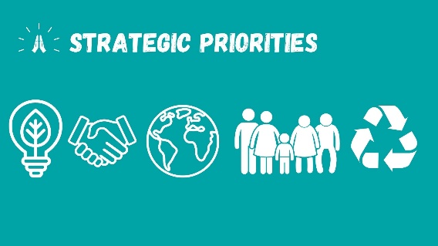
So we can be growing new communities, be reconciling, intercultural, intergenerational, ecological communities as we continue to commit ourselves to each other, and to God. To being shaped by God, to be a church fit for the future and confident to share the good news in the here and now.
To do this we need to hear your voice, understand the perspectives of all of our many communities and listen to God as He leads us to be shaped by Him, together.

