Shaped By God Together all is about how we as a diocese look to God, listen to his prompting, make sense of what is happening around us, and move into the future.
It’s built on our values of: creativity, generosity and attentiveness and takes stock of where we are now as a church, where we need to be as a church going forward and is about discerning where God is leading us; understanding that there will need to be changes around the way in which we shape our ministry provision, our care for and use of our church buildings, and the principles that guide how we raise and best use our diocesan finance.
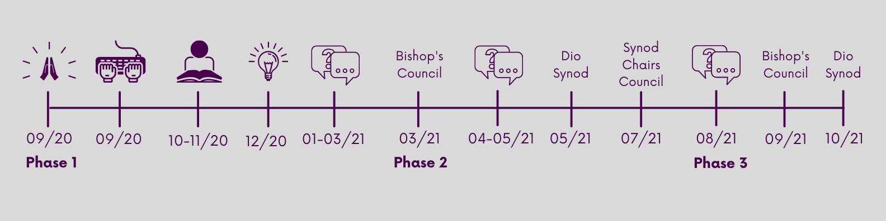
Phase 1
September 2020
- The process began in September 2020 with Bishops Martyn and Guli calling us all to pray.
- This was followed by us collecting literally hundreds of stories that you sent in about your faith and your Christian community’s experience of “everyday faith” during the first lockdown.
October – November 2020
- These stories were then reviewed and reflected on by many in the diocese and ‘made sense of’.
December 2020
- As patterns and themes emerged the stories gave us insights into where God was leading us as a diocese. These insights have been shared and can be found on the diocesan website.
January – March 2021
- Everyone from our Christian communities around the diocese were invited to join conversations about where they see the future of ministry, church buildings and finance. Conversations took place Diocesan Synod as well as between small groups over Zoom. These conversations explored a range of options of how we could do things in the future. Through these conversations feedback was gathered on the various options that had arisen from all of the hard work that has gone into the process so far.
Phase 2
- At the beginning of March Bishop’s Council looked at these options
April – June 2021
- Local conversations are taking place to look at the models of ministry that have emerged from the previous discernment and conversations.
July 2021
- With God leading us, all of these conversations and feedback will be gathered and considered by Bishop’s Council, Area Deans and Lay Chairs in July. They will then work together and recommended options to be worked into a Diocesan Framework.
Phase 3
August 2021
- Further conversations will take place over across the diocese in which we hope as many people as possible with share thoughts, give perspectives and discern together as we considering the preferred models for change.
September 2021
- Bishops Council will meet to discuss this new diocesan framework and agree a formal proposal to be taken to Diocesan Synod.
October 2021
- A Synod meeting will then take place in October during which a decision regarding a new Diocesan Framework will be taken.
We don’t yet know which of the options will be chosen, we don’t yet have all the details worked out and we don’t know what the new framework will look like. But we do know that God is with us, is speaking to us and urging us to follow Him, to build His Kingdom. Change is not easy but we are not alone as God is shaping us… together.

