By now you may have heard of the Shaped By God Together ‘process’ that is currently being undertaken in the diocese. But what is this process? What is happening and when are the stages of this process taking place?

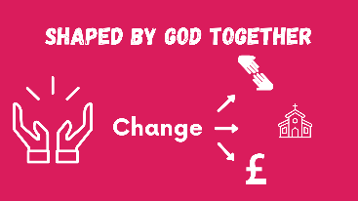
Well, Shaped By God Together all is about how we as a diocese look to God, listen to his prompting, make sense of what is happening around us, and move into the future.

It’s built on our values of: creativity, generosity and attentiveness and takes stock of where we are now as a church, where we need to be as a church going forward and is about discerning where God is leading us; understanding that there will need to be changes around the way in which we shape our ministry provision, our care for and use of our church buildings, and the principles that guide how we raise and best use our diocesan finance.
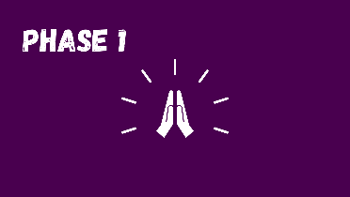
The process began with Bishops Martyn and Guli calling us all to pray. And was followed by us collecting literally hundreds of stories that you sent in about your faith and your Christian community’s experience of “everyday faith” during the first lockdown. These stories were then reviewed and reflected on by many in the diocese and ‘made sense of’. As patterns and themes emerged the stories gave us insights into where God was leading us as a diocese. These insights have been shared and can be found on the diocesan website.

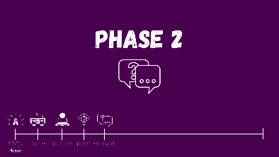
All of this work has enabled us to enter into a new phase of the process. One of conversation. We have been inviting everyone from our Christian communities around the diocese to have conversations about where they see the future of ministry, church buildings and finance. Conversations have taken place at Diocesan Synod as well as between small groups over Zoom. Through these conversations we hope to hear God’s voice as we move towards phase two…
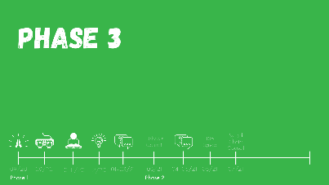
During this phase we will begin to explore a range of options of how we could do things in the future. Gathering feedback on the various options that have arisen from all of the hard work that has gone into the process so far. At the beginning of March Bishop’s Council will start to look at these options along with other groups and meetings across the diocese and we hope every one of you will join in to some of those conversations in April and May - we will we share details about them soon. The options will also be discussed by Diocesan Synod if May and we hope there will be some proposed principles in regards to finance and ministry investment discussed on this date.
With God leading us, all of these conversations and feedback will be gathered and considered by Bishop’s Council, Area Deans and Lay Chairs in July. They will then work together and recommended options to be worked into a Diocesan Framework… taking us into phase three of the process during which we urge as many people in the diocese as possible to share thoughts, give perspectives and discern together as we considering the preferred models for change.
Keep your eye on diocesan communications such as Diomail where we will explain how to get involved and share your thoughts throughout phase two and three!
In September Bishops Council will meet to discuss this new diocesan framework and agree a formal proposal to be taken to Diocesan Synod. A Synod meeting will then take place in October during which a decision regarding a new Diocesan Framework will be taken.

We don’t yet know what that the options are, we don’t know what the new framework will look like. But we do know that God is with us, is speaking to us and urging us to follow him, to build his Kingdom. Change is not easy but we are not alone as God is shaping us… together.

