Please pray for all those to be ordained, and especially those to be ordained in the Diocese of Leicester this Petertide.

God our Father, Lord of all the world,
through your Son you have called us
into the fellowship of your universal Church:
hear our prayer for all your faithful people
that in their vocation and ministry
each may be an instrument of your love,
and give to your servants soon to be ordained
the needful gifts of grace;
through our Lord and Saviour Jesus Christ,
who is alive and reigns with you,
in the unity of the Holy Spirit,
one God, now and for ever.
Amen.

Pray also for their families, friends and all those who will support them.

Pray for the communities where they will serve their curacy, for their training incumbents and context supervisors.

Pray too for Bishop Martyn who will preside at the ordinations, for Bishop Saju who will preach and for Dr Cathy Ross (Canon Theologian) who will lead the ordination retreat at Launde Abbey.

Pray too for more vocations to all kinds of ministry as we are Shaped By God Together.

What is God’s plan for you?
https://www.churchofengland.org/life-events/vocations
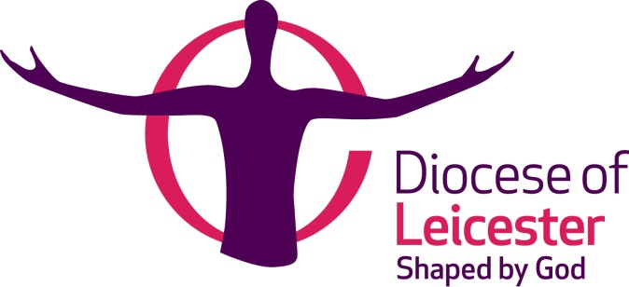

Ordinations 2022
Prayer Card

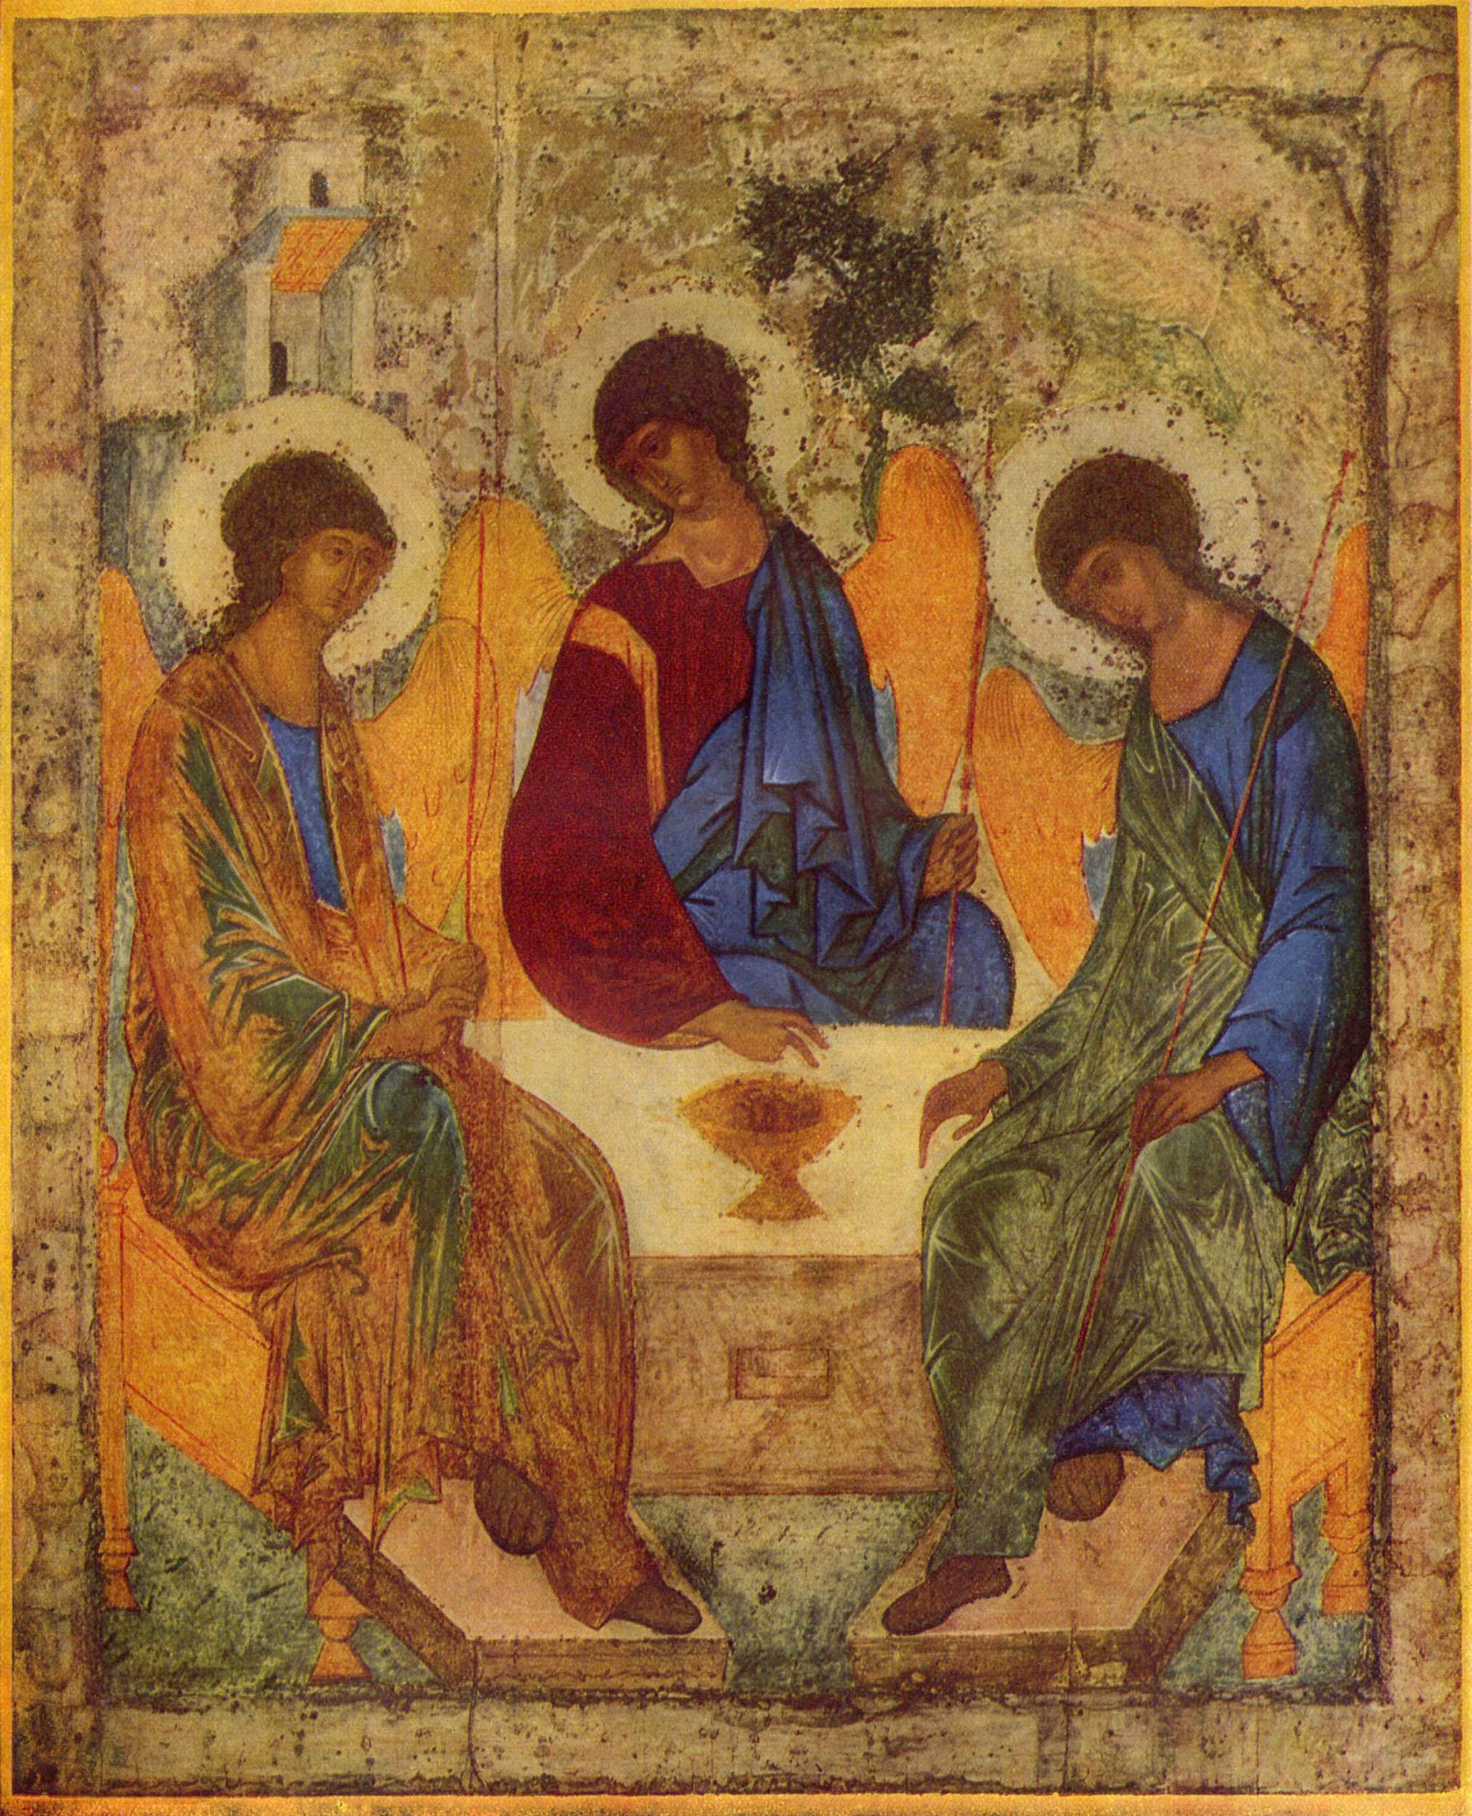

To be ordained Priest
on Saturday 2 July 2022

Paul Betts The Wigston Benefice

Luke Dobson Leicester Holy Trinity with St John the Divine

Tom Grant Market Harborough and the Transfiguration – Little Bowden with Lubenham and Great Bowden

Stephen March The Hexagon Benefice

Charles Ndigirwa Leicester, St Christopher

Rhianne O’Rourke Coalville with Bardon Hill and Ravenstone

Steve O’Rourke Hugglescote with Donington, Ellistown and Snibston

David Palmer “Elderberries” and “Tea@3” Fresh Expressions in the Harborough Anglican Team

Liz Piki Loughborough, All Saints with Holy Trinity

Manuela Schmuki Leicester Cathedral

Ali Simpson-Smith The Emmaus Parish Team (St John the Baptist, Clarendon Park)

Steve Sweet The Cornerstone Team

Kate Szejnmann Leicester, Holy Apostles

Ben Williams The Oadby Great Glen Team Ministry

To be ordained Deacon
on Sunday 3 July 2022

Mark Batchelor Evington

Matthew Green Castle Donington

David Lewis The Emmaus Parish Team (St John the Baptist, Clarendon Park)

Katherine
Marjoribanks Emmanuel Loughborough

Sharon Plant Leicester St Anne, St Paul and St Augustine

Phillippa Taylor The Martyrs

Riffat Zamurad Groby and Ratby

