

The Diocese of Leicester has a vision for the Kingdom of God, and as part of that vision we are seeking to be ‘Shaped By God Together’.

This longstanding strategy requires a new shape of organizing for mission and ministry. In 2021 our Diocesan Synod agreed a framework for mission which we call ‘Minster Communities’. We are now working across the diocese to form Minster Communities, over the next 2-3 years, through a facilitated, participatory process.

**We are seeking expressions of interest for Area Facilitators and Co-Facilitators for the Minster Community formation process.**

We have some funds available (from a national church grant),and are seeking people willing to work on a sessional basis in either a paid or voluntary capacity as outlined below. Leicester diocese stipendiary clergy are also able to express an interest as part of their existing conditions.

For an information pack please contact: Beth Cluer [beth.cluer@leicestercofe.org](mailto:beth.cluer@leicestercofe.org) / Stuart Burns [stuart.burns@leicestercofe.org](mailto:stuart.burns@leicestercofe.org)

# **The Minster Community Formation Process**

Through piloting in a number of areas, we have developed the process for forming Minster Communities. This process is participatory and based within Christian Discernment, and draws from an understanding of working in complexity. Through the process we seek to enable people in parishes, fresh expressions and schools to honestly grapple with our boundaries of resources and identity, and seek to focus on our diocesan Three Key Questions and priorities of Eco, Reconciliation, Intercultural, Intergenerational, and New Communities.

Phase 1 (“Preparing”) of the process begins with a large group of churches across a wide geographical area. This phase focuses churches on getting to know themselves and each other. The process then enables the large group to form into a set number of smaller potential Minster Community groupings for Phase 2 (“Forming”). Phase 2 is when the detailed work is done to create a proposal for each Minster Community. Following a formal launch service, Phase 3 (“Living”) is when structures and governance are formalised and deployment agreed, with churches working together in mission becoming a lived reality.

# Area Facilitators

Area Facilitators are needed for the Minster Community formation process across a geographical area of the diocese.

We are looking for up to 3 highly-experienced and skilled process facilitators, to work on a contracted basis across a geographical area to deliver the Minster Community formation process. They will work alongside a number of Co-Facilitators and be supported by the diocesan Parish Transition and Ministry Development team.

As well as being the overall Area Facilitator they will act in a Co-Facilitator capacity for one of the Minster Communities that are forming from the overall area. They will support and accompany diocesan officers, parishes, fresh expressions and schools as they journey to becoming a Minster Community.

Remuneration will range from £300-£500 per day depending on skills and experience, for up to 35 days per area. We anticipate this being spread over an 18-month period. These days include preparation/administration time at an agreed rate.

## Co-Facilitators

Co-facilitators are needed for the Minster Community formation process. They will work in pairs, in Phase 2 of the Minster Community formation process, with specific groups of parishes, fresh expressions and schools as they undertake detailed work to explore possibilities and create a Minster Community proposal. They will be supported by the diocesan Parish Transition and Ministry Development Team.

Some Co-Facilitators will also work alongside Area Facilitators in Phase 1 of the process. Co-Facilitators may also be invited to accompany Minster Community ministry teams as they form and start working together in the months immediately following the Minster Community launch (Phase 3).

We are looking for people who are willing to work on a voluntary or pro-bono basis (agreed expenses provided). We anticipate the time commitment being a maximum of 35 days over 18 months for Co-Facilitators involved in both Phase 1 and 2. Phase 2 alone is estimated to be up to 2/3rds of this commitment.

**Expressions of interest**

Please provide an Expression of Interest to [Beth.Cluer@LeicesterCofE.org](mailto:Beth.Cluer@LeicesterCofE.org)  by 15/9/23

Please include in your expression of interest any relevant experience, any relevant qualifications, contact details for at least 2 references and testimonials.

#### Area Facilitators

**Area Facilitators are needed to enable us to support and accompany diocesan officers, parishes, fresh expressions and schools as they journey to becoming a Minster Community.**

**We are looking for up to 3 Area Facilitators, to work on a contracted basis, across a geographical area to deliver the Minster Community formation process. Area facilitators will lead the large-group area process (Phase 1), and also act as a Co-Facilitator to work alongside a specific Minster Community in Phase 2. This process is participatory and based within Christian Discernment, and draws from an understanding of working in complexity.** **They will be supported by the diocesan Parish Transition and Ministry Development department. These roles will work to a staggered timeline and therefore have different start dates.**

Role description

**Through process facilitation, to deliver the Minster Community Formation process for a designated area, forming a number of Minster Communities.**

**To also act as a Co-Facilitator for one Minster Community.**

This will include:

Planning and leading the overall formation process of community discernment using our pre-designed process over an 18-month period* for a specific geographical area.

Hosting and resourcing the relevant local Co-ordinating Group through Phases 1 and 2 to ensure they make proper preparation and enable the best conversations possible within the formation process.

Sharing and capturing process and progress feedback to the Shaped by God Together Steering Group, including some use of project management software (access and training will be provided).

Responding appropriately and within agreed timescales to queries and questions of process throughout the formation process.

To act as a Co-Facilitator for 1 specific Minster Community as it forms through Phase 2.

Ensuring Phase 2 Working Groups complete their tasks on time, supporting specific groups when necessary.

In addition to facilitation, to ensure that the draft and final paperwork for diocesan approval is completed.

Ensuring a smooth transition into facilitator and diocesan support for phase 3, and working within phase 3, when appropriate.

Liaising with relevant diocesan officers and support staff.

*This role will require evening and weekend working over an 18-month period, and the work will ebb and flow as the process unfolds, with unevenly distributed events throughout. Some of the meetings can be supported or delivered by Zoom, and there may be flexibility offered around scheduling.

Remuneration will range from £300-£500 per day depending on skills and experience, for up to 35 days per area. These days include preparation/administration time at an agreed rate. Area Facilitators will need to arrange their own transport across the diocese.

Qualities needed include:

A person of faith & prayer and who understands the realities and challenges of Christian discernment.

To be aware of the diocesan Shaped By God Together Minster Communities framework, and willing to work outside of their own ‘local’ church, school or fresh expression of church.

Committed to equality of voice, and passionate about ensuring all are heard.

Ability to relate across theological traditions.

Understand change and high levels of complexity, and yet able to stick to agreed processes.

Confident in their ability to create, hold and navigate a space for conversations & discernment.

Confident and skilled to lead and facilitate large group conversations (100+).

Able to deal with high emotions and working with challenge and disagreement

Able to form and ask questions that release and unlock when people and communities are stuck.

Able to hold confidentiality.

Able to listen attentively and deeply to communities and individuals.

Able to hold their silence and not to rush to solve.

Willing to reflect on their own practice and experience.

Able to manage your own anxieties, and cope with disruption.

Have a good understanding of Church of England parish life.

##### Co-Facilitators

**Co-facilitators are needed for the Minster Community formation process. They will work in pairs, in Phase 2 of the Minster Community formation process, with specific groups of parishes, fresh expressions and schools as they undertake detailed work to explore possibilities and create a Minster Community proposal. This process is participatory and based within Christian Discernment, and draws from an understanding of working in complexity.** **They will be supported by the diocesan Parish Transition and Ministry Development Team.**

**Some Co-Facilitators will also work alongside Area Facilitators in Phase 1 of the process. Co-Facilitators may be invited to accompany Minster Community ministry teams as they form and start working together in the months immediately following the Minster Community launch (Phase 3).**

We are looking for people who are willing to work on a voluntary or pro-bono basis.

**At this stage in the implementation of our framework we are looking for up to 20 Co-Facilitators, although not all will be needed to begin this work immediately.**

Role description

**To co-facilitate the formation process for a designated minster community.**

This will include:

Planning and facilitating the formation process community discernment sessions using our pre-designed process over a 12-month period*

Hosting and resourcing the relevant local Co-ordinating Group through Phase 2 to ensure they make proper preparation and enable the best conversations possible within the formation process.

Responding appropriately and within agreed timescales to queries and questions of process throughout the formation process.

Sharing and capturing process and progress feedback to the Shaped by God Together Steering Group, including some use of project management software (access and training will be provided).

Ensuring Phase 2 Working Groups complete their tasks on time, supporting specific groups when necessary.

In addition to facilitation, to ensure that the draft and final paperwork for diocesan approval is completed.

Ensuring a smooth transition into facilitator and diocesan support for phase 3, and working within phase 3, when appropriate.

Liaising with relevant diocesan officers and support staff.

*Phase 2 is estimated to take between 9-12 months and involve up to 25 days of work. These roles will require evening and weekend working, and the work will ebb and flow as the process unfolds, with unevenly distributed events throughout. Some of the meetings can be supported or delivered by Zoom, and there may be flexibility offered around scheduling.

For those Co-Facilitators also working in Phase 1 of the process, this would extend the work to up to 35 days over an 18-month period. Phase 1 Co-Facilitators will work with an Area Facilitator.

Co-Facilitators will need to arrange their own transport across the diocese. Agreed expenses (including for travel) will be provided.

Existing stipendiary clergy within the Diocese of Leicester are able to express an interest, (working within their current terms of service). For an initial conversation or more information please contact [Stuart.Burns@LeicesterCofE.org](mailto:Stuart.Burns@LeicesterCofE.org) or [Beth.Cluer@LeicesterCofE.org](mailto:Beth.Cluer@LeicesterCofE.org)

Qualities needed include:

A person of faith & prayer and who understands the realities and challenges of Christian discernment.

To be aware of the diocesan Shaped By God Together Minster Communities framework, and willing to work outside of their own ‘local’ church, school or fresh expression of church.

Committed to equality of voice, and passionate about ensuring all are heard.

Ability to relate across theological traditions.

Understand change and complexity, and yet able to stick to agreed processes.

Confident in their ability to create, hold and navigate a space for conversations & discernment.

Able to support and challenge as the situation requires.

Able to form and ask questions that release and unlock when people and communities are stuck.

Able to hold confidentiality

Able to listen attentively and deeply to communities and individuals.

Able to hold their silence and not to rush to solve.

Willing to reflect on their own practice and experience.

Able to manage your own anxieties, and cope with disruption.

Have a good understanding of Church of England parish life.

**Further Information**

### Structure

**Facilitator allocation process summary**

After expressions of interest have been received, individuals will be invited for further conversations with a view to exploring possibilities for this work. The Director of PTMD and the Senior Parish Transition Officer will work together with the applicants to ascertain best fit.

**Time commitment: Area Facilitator**

We envisage that for the Area Facilitator up to 35 days over the course of 18 months will be needed. There will be some time required to bring yourself up to speed on the existing process, and on the SBGT strategy as a whole.

These roles will require evening and weekend working, and the work will ebb and flow as the process unfolds, with unevenly distributed events throughout. Some of the meetings can be supported or delivered by Zoom, and there may be flexibility offered around scheduling. The MC Coordinating group meetings are more flexible in time and frequency. The current practice is 90 mins every month.

Administration support for meeting preparation is available as part of the wider diocesan office support. Facilitation kit and consumables are provided through PTMD. At the end of the process a phased exit may be required, depending upon recommendations given to the Minister Community as part of their application to Bishop’s Council.

**Time commitment: Co-Facilitator**

Phase 2 is estimated to take between 9-12 months and involve up to 25 days of work.

For those Co-Facilitators also working in Phase 1 of the process, this would extend the work to up to 35 days over an 18-month period. Phase 1 Co-Facilitators will work with an Area Facilitator.

There will be some time required to bring yourself up to speed on the existing process, and on the SBGT strategy as a whole.

These roles will require evening and weekend working, and the work will ebb and flow as the process unfolds, with unevenly distributed events throughout. Some of the meetings can be supported or delivered by Zoom, and there may be flexibility offered around scheduling. Many of our larger events occur during evening or weekends. The MC Coordinating group meetings are more flexible in time and frequency. The current practice is 90 mins every month.

Administration support for meeting preparation is available as part of the wider diocesan office support. Facilitation kit and consumables are provided through PTMD. At the end of the process a phased exit may be required, depending upon recommendations given to the Minister Community as part of their application to Bishop’s Council.

**Working with a Co-Facilitator**

Area Facilitators will have at least one Co-Facilitator working alongside them in Phase 1 of the process of forming Minster Communities.

2 Co-Facilitators will together take responsibility for the Phase 2 process of formation of a Minster Community.

**Support offered**

Administrative support is provided through the PTMD / SBGT office. A regular facilitator group meet up (fortnightly, for 75 mins) is available for support / process questions / issues arising.

The Senior Parish Transition Officer and Facilitation Lead has responsibility for provision of additional training and supporting all facilitators.

Overall Shaped By God Together programme management is through the SBGT Programme Team led by the Diocesan Programme Manager (Claire Bampton).

Access to some diocesan IT and files will be necessary, and IT access for volunteers will need to be agreed.

**Review process**

Regular reports will be provided to the SBGT Steering Group, that consists of the SBGT programme Manager, the Director of PTMD, the Archdeacons, and the Senior Parish Transition Enabler.

A facilitation review process will be in place, with key reviews undertaken at agreed process milestones.

**Insurance**

Cover for facilitation is provided through our diocesan insurance scheme. This includes liability and indemnity cover.

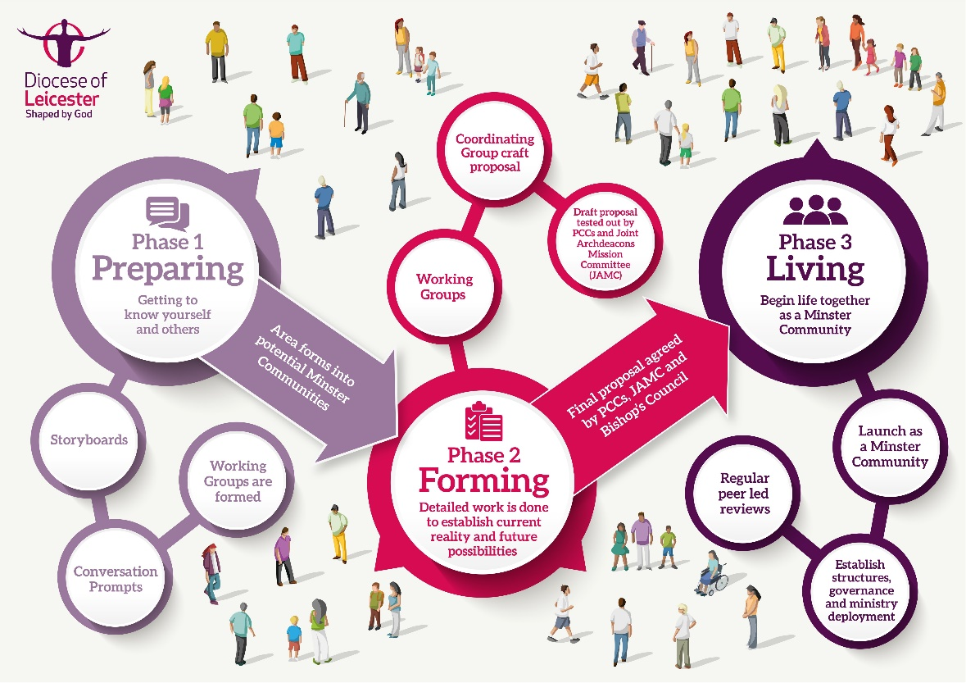**Process summary**

**Process information**

Phase 1 (“Preparing”) of the process begins with a large group of churches across a wide geographical area. This phase focuses churches on getting to know themselves and each other. We have developed two tools for use in this Phase: Storyboards and Conversation Prompts. The process then enables the large group to form into a set number of smaller potential Minster Community groupings for Phase 2 (“Forming”). Phase 2 is when the detailed work is done to create a proposal for each Minster Community. We have developed templates to guide Working Groups and Co-ordinating Groups through this Phase. Following a formal launch service, Phase 3 (“Living”) is when structures and governance are formalised and deployment agreed, with churches working together in mission becoming a lived reality. Archdeacons and the PTMD team offer tailored support during Phase 3.

General information about Shaped By God Together, including the journey so far and Frequently Asked Questions can be found on the website: <https://www.leicester.anglican.org/about-us/sbgt/>

Further information about Minster Communities is available on the Learning Hub: <https://thehub.leicester.anglican.org/category/minster-communities/>

More detailed information is available from [stuart.burns@leicestercofe.org](mailto:stuart.burns@leicestercofe.org) or [beth.cluer@leicestercofe.org](mailto:beth.cluer@leicestercofe.org)

**Minster Community Co-ordinating Group (Terms of Reference)**

The Minster Community Co-ordinating Group will be the place where local engagement with the **Minster Community** **process** is enabled. Each emergent Minster Community will have a Co-ordinating Group. The Co-ordinating Group will not be a decision-making body.  However, it may be asked to make some recommendations during the process; responsibilities for decisions will remain with the parishes.

 The group will have the following responsibilities

* To guide and advise Parishes / Fresh Expressions (FxC) / Schools to ensure they make proper preparation to enable the best conversations they can have within the context of the Minster Community (MC) formation process.
* To work with the Parish Transition and Ministry Development (PTMD) team. PTMD facilitators to support practical arrangements, set dates, venues and method of meeting (e.g. Zoom, Teams, Physically in-person).
* To work with the wider MC to craft any papers / proposals that will be submitted to the Joint Archdeaconry Mission Committee (JAMC) in due course.

Each emergent Minster Community will have designated facilitators, co-ordinated by the Parish Transition & Ministry Development Team.