Shaped By God Together – Local Conversations
Pre-session preparation
Bishop Martyn has asked that each church community have a conversation about three possible model of ministry for the future in our diocese, and to feedback reflections into the larger diocesan conversation and discernment process. You will soon be doing this with your local team. Before you meet it will be helpful to have some background knowledge and understanding of the Shaped By God Together process and why these changes are taking place. Please spend around half an hour exploring the resources below before your meeting.

Why Shaped By God Together
This short video gives the background reasoning behind the process and explains why we need to change our current framework as a diocese.
If you are unable to access an online video there is a printable offline document that can be downloaded here.

The SBGT Timeline
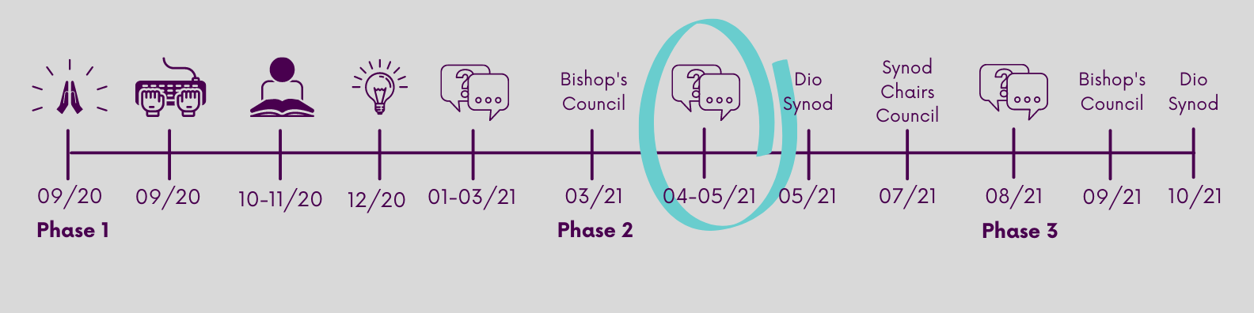
This conversation is taking place as part of phase 2 of the process.
If you’d like to understand a more detailed picture of the timeline for SBGT then there is an additional video on this subject which can be viewed here: https://youtu.be/zxQAPbTUV54. The transcript of which can be downloaded here. Or read a one page document that can be found here.

Big Insights
The many stories that were gathered at throughout the summer of 2020 gave us some really important insights which have and will continue to feed into this process. A summary of these insights and some of the questions they raise can be found here: Diocese of Leicester | Shaped By God Together – further insights from your stories (anglican.org)

Finance and Buildings
The Shaped By God Together process has been focusing future shape of our Ministry, our care for and use of our Church Buildings, and the principles that guide how we raise and best use our diocesan Finance. The local evenings will focus on three potential models for ministry but you can read an update from the finance conversations here and building conversations here.

Add details of your local conversation here:
Location/Zoom details
Time

SBGT Conversation Ground rules:
Everyone has something to share.
Everyone has something to receive.
Listen actively and attentively.
Ask for clarification if you are confused.
Do not interrupt one another.
Challenge one another but do so respectfully.
Critique, or discuss ideas, not people.
Everyone takes responsibility for the quality of the conversation.
Build on one another’s comments; work towards shared understanding and quality feedback.

Consider anything said in the conversation as confidential, do not share another’s story without their permission.

Trust the conversation host and make this as easy as possible for them.

