Diocese of Leicester

**Job Description**

**Job Title:** Bishops’ Communications Manager (Maternity Cover)

**Purpose of role:** To facilitate the ministries of the Bishop of Leicester and the Bishop of Loughborough through liaison with the press and other media, and communication with stakeholders both internally within the diocese and externally within the city, county and where appropriate, nationally.

**Accountable to:** Bishop of Leicester

**Location:** Bishop’s Lodge, 12 Springfield Road, Leicester LE2 3BD (with agreement to also work remotely)

**Hours:** This is a one-year fixed term (maternity cover) part-time post (17.5 hours) with some flexibility required for evenings and weekends

***Background to this role:***

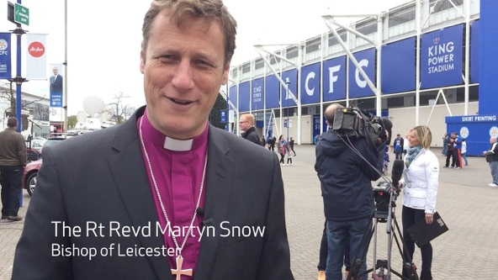The Bishops of Leicester and Loughborough share leadership of the Church of England in the Diocese of Leicester (covering the city of Leicester and the county of Leicestershire). The Bishop of Leicester is a member of the House of Lords and carries various responsibilities within the city of Leicester, the county of Leicestershire, and the national Church of England. The Adviser will work closely with Bishop Martyn on his work in the House of Lords and his engagement with civic, business and charity leaders in the city and county.

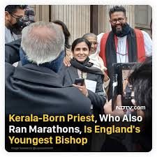Both bishops, and many clergy and diocesan staff make regular appearances on local TV, radio and print media. Together with the diocese, they have a significant presence on social media (although there is potential for this to grow). Often this involves proactive engagement to share good news stories of what churches in the diocese are doing. Sometimes it is reactive to enquiries about the church. In recent years, we have had a number of occasions when we have become the focus of national press e.g. the reburial of King Richard III in Leicester Cathedral in 2015, the success of Leicester City Football Club in 2016; a visit by HM The Queen in 2017; a helicopter crash which killed the owner of Leicester City Football Club in 2018; the prolonged lockdowns in Leicester in 2020; stories of ‘sweatshops’ in Leicester clothing industry in 2021; Bishop Martyn’s maiden speech in the House of Lords in 2022.

In addition, the Diocese of Leicester is going through a major change programme. In 2017, the Bishop of Leicester articulated a high-level strategy for the diocese in terms of seeking to grow the Kingdom of God through three key questions which he asked all clergy and all parishes to answer:

1. A person and person sitting in a chair

   Description automatically generatedHow are you growing, and enabling others to grow in the depth of your discipleship?
2. How are you growing, and enabling others to grow the numbers of disciples?
3. How are you growing, and enabling others to grow in loving service of the world?

In 2019, five strategic priorities were added:

1. **New Communities** – reimagining church for those who don’t do church.
2. **Intercultural Communities** – reimagining church as a place where people of different cultures worship, celebrate and share together.
3. **Intergenerational Communities** – reimagining church as a place where people of different ages worship, celebrate and share together.
4. **Eco Communities** – reimagining church as a place where creation is celebrated and nurtured.
5. **Reconciling Communities** – (reimagining church as a place where people with different views live well together.

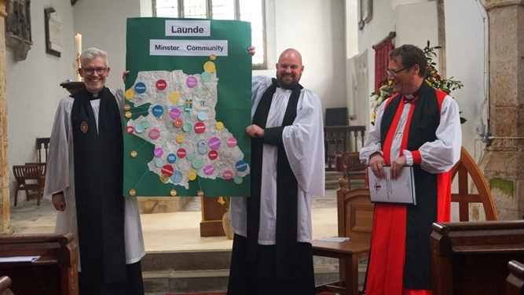

In 2021, the bishops instigated a process for the formation of Minster Communities as a new structure for mission and ministry in the diocese. Three pilots are underway, and plans are in place for rolling out the new structure across the diocese. This is a major whole-diocese change programme requiring significant stakeholder engagement and communication.

This level of change combined with the pandemic, financial challenges for the diocese, and other major changes in the national church has caused increased levels of anxiety in parishes. The bishops have a significant role in pastoral care of clergy and lay leaders.

As well as working directly with the bishops, the Adviser will also coordinate the work of two part-time Communications Officers (Story Gathering & Minster Communities). The current post-holder will go on maternity leave in mid-June 2024. We want to ensure a good handover so the maternity cover will need to start around the beginning of June.

**Aims of the role:**

* Developing and delivering proactive communication campaigns seeking widespread and positive media coverage of stories concerning the church in Leicester and Leicestershire, the leadership of the Bishops, and the daily witness of both laity and clergy.
* Coordinating the media response to major events and crises, enabling the Bishops to speak prophetically and pastorally into such situations.
* Enabling good internal communication within the diocese such that the Bishops’ vision and strategy for mission and ministry are well understood and owned.
* Coordinating the work of Communications Officers and ensuring that other staff understand their role in communication and stakeholder engagement.

**Main Duties**

* Deal with enquiries from local, regional, national and international media.
* Manage and respond to day-to-day news diary and stories, proactively taking a lead and identifying good news stories or potential issues which may lead to negative coverage.
* Develop a reactive "Lines to Take" database to ensure accurate and up to date responses are given to journalists.
* Provide and/or arrange an ‘out of hours’ on-call press and media service when necessary and communicating arrangements for this.
* Provide advice and support for parishes in handling media enquiries.
* Work with the Communications Officers and other staff to develop communications strategies to support the work of other diocesan teams (including Finance, Generous Giving, Safeguarding and Church Buildings)
* Work with the Communications Officers and other staff to develop and deliver proactive communication campaigns, with a seasonal cycle.
* Arrange and manage interviews and other media events such as podcasts, recordings, and photo shoots.
* Oversee the production of Diomail, the weekly Diocesan e-newsletter, articles for the Diocese’s website, and regular vlogs
* Produce and schedule daily social media posts and monitor the diocese’s social media platforms (Facebook, Instagram and X)
* Manage changes to the website
* Be a member of the Diocesan Safeguarding Oversight Group and attend meetings of the Case Management and Review Group and Core Groups set up to respond to serious safeguarding situations.
* Attend Bishop’s Leadership Team, Bishop’s Council and Diocesan Synod meetings as agreed with the Bishops.
* Other duties as agreed with the Bishops.



|  |  |  |
| --- | --- | --- |
| **Person Specification**  **Essential**  **Desirable** | | |
| **Previous experience** | Good understanding of ministry in the Church of England, especially in the area of the church’s role in the public square.  Good experience in a relevant communication, journalistic or public relations role.  Experience of crisis management.  Experience of forward news planning. | Experience of working with people of different faiths. |
| **Knowledge and understanding** | Degree level qualification in theology and/or social policy.  Qualification in media, journalism, or public relations.  Knowledge of, and in sympathy with the Church of England’s vision and values | Post-graduate qualification |
| **Skills / Aptitude** | Able to articulate a theological understanding of the kingdom of God and a holistic approach to Christian mission.  Able to relate well to and influence senior leaders in various fields.  Proactive approach, with ability to spot news stories prior to publication.  Ability to work under pressure, to changing and simultaneous deadlines.  Ability to differentiate important from urgent.  Adept and fully conversant with using and understanding social media.  Excellent communication skills including written, oral, negotiating, influencing and presentation skills.  Ability to navigate effectively complex organizational structures in delivering work objectives.  Ability to relate well to people of all backgrounds.  Ability to represent the Church of England with confidence.  Excellent IT skills, including social media scheduling, Canva and video-editing  Ability to maintain a high level of confidentiality. | Experience of working with people of different faiths. |

**TERMS OF EMPLOYMENT**

***Salary***

The salary for this post is £22,500 FTE (a pro-rata amount based on a full-time salary equivalent of £45,000 per annum FTE depending on experience). The salary is in line with Band 4 of the National Church Institutions’ (NCI) pay scales.

**Pension Contributions**

Non-clergy staff will be automatically enrolled into the in the Pension Builder 2014 Pension Plan (PB2014) in line with legislation unless they choose to opt out. Clergy already in the Church of England Funded Pensions Scheme (CEFPS) will have the option of either remaining in this scheme or joining the PB14 scheme. Employees enrolled into PB2014 are required to contribute 3% of their pensionable salary. The employee can change their contribution at any time. The employer matches contributions in whole percentages up to 3%.

**Hours of work**

The hours of work will be 17.5 hours per week exclusive of a one-hour unpaid lunch break, to be taken at a time agreed with the Bishop, but some flexibility will be required from time to time, including evenings and weekends.

**Annual Leave**

An entitlement of 12.5 days paid annual leave per leave year. This is exclusive of public and additional holidays. The leave year runs from 1st January to 31st December.

**Notice**

The notice period is one month on either side or that to which the employee is entitled in accordance with current employment legislation, whichever is greater or by pay in lieu of notice by the employer. Should the employee be summarily dismissed on the grounds of gross misconduct, the employment may be terminated without notice.

**Contract**

The post is offered on a one year fixed-term contract (maternity cover), subject to a one-month probationary period.