2022 Priest Profiles

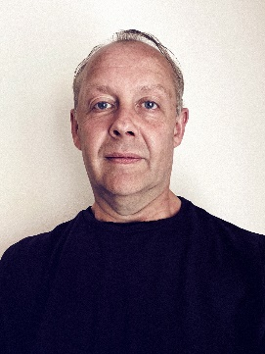  Paul Betts | Sometime ago I wrote that I believe God is calling me to give my life for service as a priest, to live that out with and for God, with and for others. This meant telling the story of God creatively and richly to a world in need of hope. I now know that sacrificial call to be realised at the altar, as well as within myself. And all this underscored by prayerful trust in the God who calls.
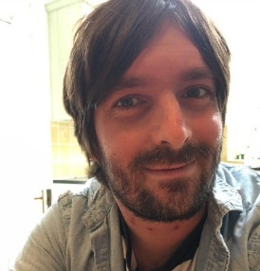  Luke Dobson | Originally from Essex, I am a husband and father of three. I have enjoyed the deacon year of my curacy, where I have been exploring weaving together Anglo-Catholic and Charismatic traditions of the church; both in terms of mission and ministry.
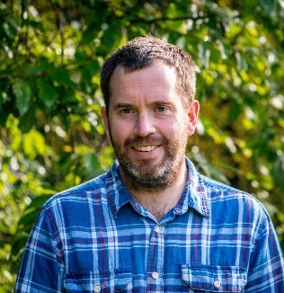  Tom Grant | My name is Tom, I am married to Jo, and we have a 5-year-old son. I enjoy running and walking in the great outdoors, as well as cooking dishes from around the world. During my Deacon year in Market Harborough, I have been forming a new team to plant a Youth-Focused Worshipping Community called ‘Limitless Church’ which will launch in September 2022.
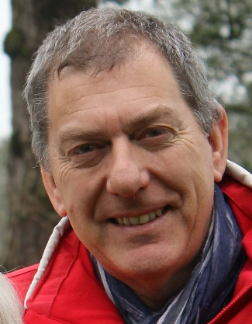  Stephen March | Having been spiritually helped and nourished by many different Christian traditions I have finally found a permanent home in the Church of England.  I love small, rural communities and am excited by the possibility of growing new congregations and supporting existing ones.  I don’t know what God has in store for me – but I hope to be surprised!
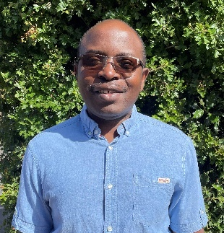  Charles Ngigirwa | I am married and have three children aged 20,15 and 12. I have felt blessed to be welcomed and accepted at St Christopher's church as they have made us feel very much part of the family of believers. I have a real heart for bringing people to the Lord and am focussing in my ministry on evangelism and prayer.
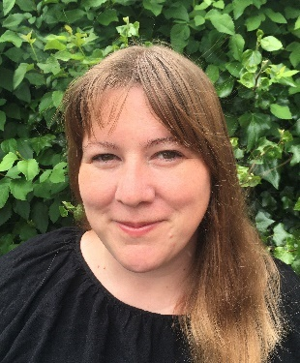  Rhianne O’Rourke | I’m a wife & mother who loves adventures with Jesus, board games, creativity & hospitality.  Being in places where church is not often found is a big part of what God is doing with me.  I’m constantly amazed by God’s goodness & mercy.
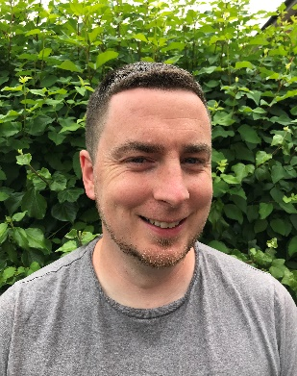  Steve O’Rourke | I’ve been married to Rhianne for 17 years and we have three boys.  It’s been a privilege to serve in Hugglescote and Ellistown as a deacon and I’m excited to now be taking the next step in ordained ministry.  My journey of faith has taught me that God is present in every part of our lives and that whatever title or role we have we’re firstly His children.
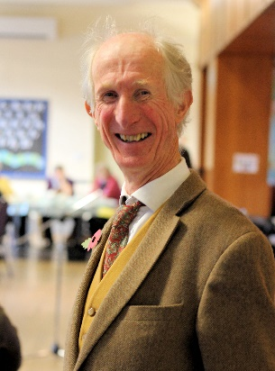  David Palmer | Married to Marie from Belgium and we have one son, Simon, an actor/writer.  Born and baptised in Canada; became confirmed aged 22 following a serious road accident.  Early career included the Wine trade; however much of my working life has been in different church/ charity contexts throughout the UK.  The next stage of my curacy will be as Pioneer Priest working with colleagues and church members across the Launde Deanery.  Interests- gardening, watercolour painting, learning French, good food/wine/conversations/friends! Newcastle Utd supporter!
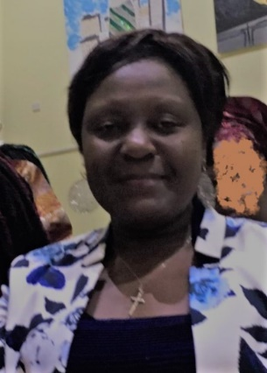  Liz Piki | I am looking forward to being ordained priest in the Diocese of Leicester. I am thankful for all the prayers and support that I have received from my family, friends, my Curacy Church family (All Saints) & Training Incumbent, our Bishops and Diocese. I would also like to thank my sending Church family (St Margaret’s Church, Leicester), our Diocesan Ministry & Development Team, my College & University tutors, the Church of the Martyrs (Leicester), the Zimbabwean Anglican Community, all clergy and lay ministers that have supported me. As well as all my prayer and fellowship networks.
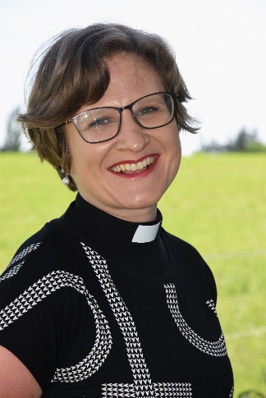  Manuela Schmucki | Manuela is curate at Leicester Cathedral and St Nicholas Church Leicester. She has a great interest in different cultures and languages and their influence on theology and worship. In her free time she likes to read, bake and run.
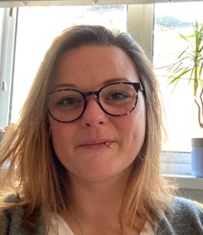  Alexis (Ali) Simpson-Smith | My Name is Ali, I’m married to Stuart, and we have a son called Joey who is growing up far too quickly!  My journey to priesthood has been colourful and eventful; it took me more than 10 years to agree to exploring my vocation into ministry. I didn’t think God would use me with my past life experiences, but then found out ministry life is full of people like me who love Jesus and are excited to share Him with those we meet on our journey.  I’ve loved being at St Johns in Clarendon Park for my training and first year of curacy whilst working alongside my Pioneer colleagues across the Diocese. Sacramental life is really important to me and I’m excited to see how God will continue to use me to share the Gospel and shape new ways of meeting as the people of God in my communities.
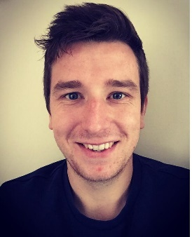  Steve Sweet | I’m very grateful to God for my family who raised me in a Jesus-centred home and who ensured I was a part of the church family from my earliest memories. Having had the opportunity to head up a youth and student ministry within a local church setting, prior to my theological training, I have enjoyed getting stuck in again to "front-line" ministry over this past year as a deacon. Sarah, my wife, and I are excited to be entering into this new chapter and to see how God will be working through the new Thurmaston church plant.
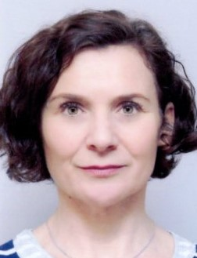  Kate Szejnmann | I started my adult life as an actor. Quite dramatically, Christ would enter my life and change its course.  I am blessed in my marriage to Chris of 25 years, and by my amazing children; Max, Laura, Ella and Grete, whom I am incredibly proud of and love dearly.  I am full of gratitude to my Jesus, for talking an ordinary girl from West London and showing her that she can do great things for God, take others on that journey, and reveal the good news of Jesus to those yet to know him.
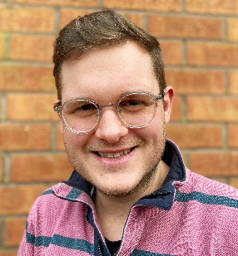  Benjamin (Ben) Williams | I am married to Emily and we have a son called Judah. I have enjoyed the chance to serve in the Benefice of Oadby and Great Glen and I am looking forward to stepping into this next phase of ministry as a priest.

