
EUCHARIST
with the Ordination of Priests

President
The Rt Revd Martyn Snow, Bishop of Leicester

Archdeacon
The Ven Claire Wood, Archdeacon of Loughborough

Preacher
The Rt Revd Dr Graham Kings

1.00pm
Sunday 13 September 2020
Please pray for all those being ordained throughout the Church at this time.
Please pray for the Colleges and Courses where candidates from our Diocese
have been trained and for the parishes in which they will continue to serve.

Those being ordained priest in this Cathedral today:

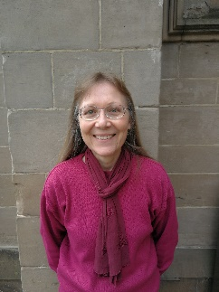  Hazel Aucken | 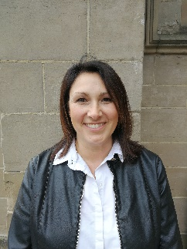  Sarah Collins | 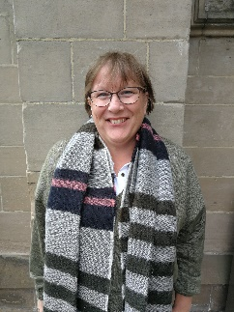  Laura Jackson
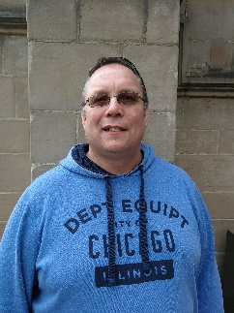  Ivan Bennett |   Mark Cooper | 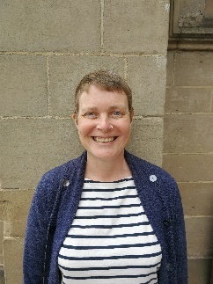  Emily Sharman
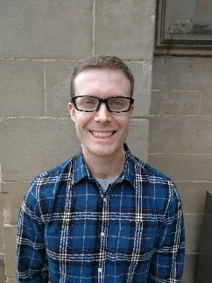  Jon Berry | 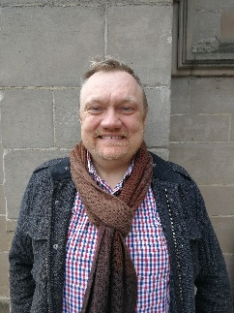  Matthew Gough | 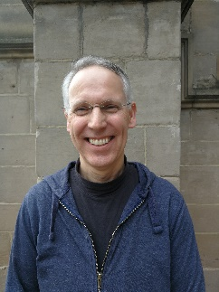  Chris Szejnmann
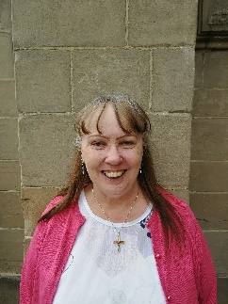  Wilma Colley | 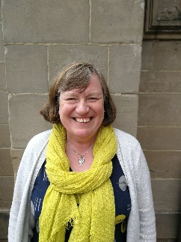  Ann Hall | 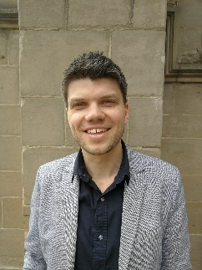  Jon Tearne

Safety Note

In case of emergency, please follow the direction of the Wardens to your nearest exit.

Additional Information

COVID-19 information: We have spaced out chairs so that you should be physically-distanced from anyone not in your household or bubble. Sanitiser is available at the door if you need it and will be brought to you at the time of Communion. Please wear a face covering while in the Cathedral unless you are exempt from doing so for any reason. If you have any concerns or questions please ask the Verger or one of the duty Wardens on the door.


Visitors to the Cathedral are requested to note that the use of all audio and visual equipment is not permitted during worship. Your cooperation is appreciated.

If you are a visitor requiring a hearing loop, please ask one of the wardens and one will be provided for you.

When prompted to stand, please only do so if you feel able.

Please note that toilets are not available in the Cathedral during the Service. However, toilets are available in Saint Martins House next door. Please ask one of the duty Wardens who will be happy to direct you.

This service is being livestreamed and will be available to watch again on YouTube.

Do you still need my donation?
Thank you for asking this question. We do understand that not everyone will be able to help in this uncertain climate. But if you are able to continue your giving, or to make a donation now, it will be enormously helpful.
We have limited reserves, our earned income has come to a standstill, and giving by collection plate and envelope has ceased. Whilst we have taken what steps we can to mitigate the effects of all this, including furloughing some staff, the costs of running and maintaining the Cathedral continue. As a result, we are experiencing very real financial pressures.
Donate online at www.leicestercathedral.org/donate
There you can set up a regular gift via the Parish Giving Scheme
You can also Text the word PLATE to 70191 (for £10) or 70970 (£5).

Introduction

Ordination is not just a special moment for the individual concerned but also for their family, friends and indeed the whole church. So we are very pleased to welcome you to Leicester Cathedral today for this deeply significant service, recognizing that you represent others too who aren’t able to be here.

God’s call comes to us in many different ways. Each person being ordained has their own story to tell about how God called them and how their response led to this moment. Some of you will have accompanied them on this journey of exploring God’s call. Some of you may even sense within this service “the faintest echo of a whisper of the voice of the God” calling you. If so, please don’t be afraid to speak to someone about this. Most of us start off thinking “God would never call me” but the truth is that God calls every one of us – some to ordination, some to lay ministry in the church, some to the ministry of healing, teaching, administration or service in the wider world. The important thing is not to ignore God’s call because it truly is the path to fulfillment and purpose in life.

So we invite you to pray with us for those being ordained, and to commit yourself to go on praying for them and supporting them in their ministry. There are many challenges in today’s world and we need ordained priests and deacons to both remind us that God is present and active in the world and also help us make sense of it all.

Thank you for being a part of today’s service.
Bishop Martyn and Bishop Guli

The Declaration of Assent and Oaths

Before the service the candidates will have made the Declaration of Assent and taken the Oaths of Allegiance and of Canonical Obedience.

The Declaration of Assent

Preface (spoken by the Bishop):

The Church of England is part of the One, Holy, Catholic and Apostolic Church worshipping the one true God, Father, Son and Holy Spirit. It professes the faith uniquely revealed in the Holy Scriptures and set forth in the catholic creeds, which faith the Church is called upon to proclaim afresh in each generation. Led by the Holy Spirit, it has borne witness to Christian truth in its historic formularies, the Thirty-nine Articles of Religion, the Book of Common Prayer and the Ordering of Bishops, Priests and Deacons. In the declaration you are about to make will you affirm your loyalty to this inheritance of faith as your inspiration and guidance under God in bringing the grace and truth of Christ to this generation and making him known to those in your care?

Candidate: I, N, do so affirm and accordingly declare my belief in the faith which is revealed in the Holy Scriptures and set forth in the catholic creeds and to which the historic formularies of the Church of England bear witness; and in public prayer and administration of the sacraments, I will use only the forms of service which are authorised or allowed by Canon.

The Oath of Allegiance

I, N, do swear that I will be faithful and bear true allegiance to Her Majesty Queen Elizabeth II, her heirs and successors, according to law: So help me God.

The Oath of Canonical Obedience

I, N, do swear by Almighty God that I will pay true and canonical obedience to the Bishop of Leicester and his successors, in all things lawful and honest: So help me God.

Gathering

The Associate Cathedral Organist, David Cowen, plays as we gather.
15 minutes before the service begins, Canon Emma Davies, Acting Canon Precentor, gives a welcome to the Cathedral and some announcements.
10 minutes before the service begins, the Ordinands and their Training Incumbents enter the Cathedral and take their seats.

The service begins when the bishops and other ministers enter in procession. Please stand.

PROCESSION
The Revd Canon Paul Rattigan, Diocesan Director of Ordinands & Canon Chancellor
The Rt Revd Dr Graham Kings
The Ven Claire Wood, Archdeacon of Loughborough
The Rt Revd Dr Guli Francis-Dehqani, Bishop of Loughborough
The Rt Revd Martyn Snow, Bishop of Leicester

* * *

All remain standing. The Right Revd Martyn Snow, Bishop of Leicester, leads

The Greeting

Blessed be God, Father, Son and Holy Spirit.
Blessed be his kingdom, now and for ever.
Amen.

There is one body and one spirit.
There is one hope to which we were called;

one Lord, one faith, one baptism,
one God and Father of all.

Peace be with you
and also with you.

All sit for

The Introduction

The Bishop welcomes the Congregation and introduces the Service.

God calls his people to follow Christ, and forms us into a royal priesthood, a holy nation, to declare the wonderful deeds of him who has called us out of darkness into his marvellous light. The Church is the Body of Christ, the people of God and the dwelling-place of the Holy Spirit. In baptism the whole Church is summoned to witness to God’s love and to work for the coming of his kingdom.

To serve this royal priesthood, God has given particular ministries. Priests are ordained to lead God’s people in the offering of praise and the proclamation of the gospel. They share with the Bishop in the oversight of the Church, delighting in its beauty and rejoicing in its well-being.

They are to set the example of the Good Shepherd always before them as the pattern of their calling. With the Bishop and their fellow presbyters, they are to sustain the community of the faithful by the ministry of word and sacrament, that we all may grow into the fullness of Christ and be a living sacrifice acceptable to God.

All remain seated for

The Presentation

The Ven Claire Wood, Archdeacon of Loughborough, stands and presents those to be ordained priest to the Bishop.

Bishop Martyn, we present to be ordained to the office of priest in the Church of God, Hazel Aucken, Ivan Bennett, Jon Berry and Wilma Colley.

When the Ordinands have been presented, the Bishop asks these questions, to which their training incumbents respond together:

Have those whose duty it is to know these Ordinands, and examine them, found them to be of godly life and sound learning?
They have.

Do they believe them to be duly called to serve God in this ministry?
They do.
The Bishop turns to the Ordinands and says:

Do you believe that God is calling you to this ministry?

Ordinands I do so believe.

The Bishop continues:
I invite the Archdeacon of Loughborough to confirm that the Ordinands have taken the necessary Oaths and made the Declaration of Assent.

Archdeacon: They have duly taken the Oath of Allegiance to the Sovereign and the Oath of Canonical Obedience to the Bishop. They have affirmed and declared their belief in ‘the faith which is revealed in the Holy Scriptures and set forth in the catholic creeds and to which the historic formularies of the Church of England bear witness’.

All stand. The Bishop leads

The Collect

Let us pray for Hazel, Ivan, Jon and Wilma,
for all who are being ordained here today,
and for the ministry of the whole people of God.

God our Father, Lord of all the world,
through your Son you have called us
into the fellowship of your universal Church:
hear our prayer for your faithful people
that in their vocation and ministry
each may be an instrument of your love,
and give to your servants now to be ordained
the needful gifts of grace;
through our Lord and Saviour Jesus Christ,
who is alive and reigns with you,
in the unity of the Holy Spirit,
one God, now and for ever.
Amen.

The Liturgy of the Word

All sit for

The First Reading

Ruth 1.8–18

Read by Bev Collett, Head Verger

A reading from the Book of Ruth.

But Naomi said to her two daughters-in-law, ‘Go back each of you to your mother’s house. May the Lord deal kindly with you, as you have dealt with the dead and with me. The Lord grant that you may find security, each of you in the house of your husband.’ Then she kissed them, and they wept aloud. They said to her, ‘No, we will return with you to your people.’ But Naomi said, ‘Turn back, my daughters, why will you go with me? Do I still have sons in my womb that they may become your husbands? Turn back, my daughters, go your way, for I am too old to have a husband. Even if I thought there was hope for me, even if I should have a husband tonight and bear sons, would you then wait until they were grown? Would you then refrain from marrying? No, my daughters, it has been far more bitter for me than for you, because the hand of the Lord has turned against me.’ Then they wept aloud again. Orpah kissed her mother-in-law, but Ruth clung to her.
So she said, ‘See, your sister-in-law has gone back to her people and to her gods; return after your sister-in-law.’ But Ruth said,
‘Do not press me to leave you
or to turn back from following you!
Where you go, I will go;
where you lodge, I will lodge;
your people shall be my people,
and your God my God.
Where you die, I will die—
there will I be buried.
May the Lord do thus and so to me,
and more as well,
if even death parts me from you!’
When Naomi saw that she was determined to go with her, she said no more to her.

Hear the word of the Lord.
Thanks be to God.

All stand. The Rt Revd Dr Guli Francis-Dehqani, Bishop of Loughborough reads

The Gospel Reading
Mark 8.27–38

The Lord be with you
and also with you.

Hear the Gospel of our Lord Jesus Christ according to Mark.
Glory to you, O Lord.

Jesus went on with his disciples to the villages of Caesarea Philippi; and on the way he asked his disciples, ‘Who do people say that I am?’ And they answered him, ‘John the Baptist; and others, Elijah; and still others, one of the prophets.’ He asked them, ‘But who do you say that I am?’ Peter answered him, ‘You are the Messiah.’ And he sternly ordered them not to tell anyone about him.

Then he began to teach them that the Son of Man must undergo great suffering, and be rejected by the elders, the chief priests, and the scribes, and be killed, and after three days rise again. He said all this quite openly. And Peter took him aside and began to rebuke him. But turning and looking at his disciples, he rebuked Peter and said, ‘Get behind me, Satan! For you are setting your mind not on divine things but on human things.’

He called the crowd with his disciples, and said to them, ‘If any want to become my followers, let them deny themselves and take up their cross and follow me. For those who want to save their life will lose it, and those who lose their life for my sake, and for the sake of the gospel, will save it. For what will it profit them to gain the whole world and forfeit their life? Indeed, what can they give in return for their life? Those who are ashamed of me and of my words in this adulterous and sinful generation, of them the Son of Man will also be ashamed when he comes in the glory of his Father with the holy angels.’

This is the Gospel of the Lord.
Praise to you, O Christ.

All sit for

The Sermon
The Rt Revd Dr Graham Kings

The Sermon is followed by short reflective organ music.
The Liturgy of Ordination

All remain seated for

The Declarations

The Ordinands stand and the Bishop of Leicester addresses the Congregation:

Priests are called to be servants and shepherds among the people to whom they are sent. With their Bishop and fellow ministers, they are to proclaim the word of the Lord and to watch for the signs of God’s new creation. They are to be messengers, watchmen and stewards of the Lord; they are to teach and to admonish, to feed and provide for his family, to search for his children in the wilderness of this world’s temptations, and to guide them through its confusions, that they may be saved through Christ for ever. Formed by the word, they are to call their hearers to repentance and to declare in Christ’s name the absolution and forgiveness of their sins.

With all God’s people, they are to tell the story of God’s love. They are to baptize new disciples in the name of the Father, and of the Son, and of the Holy Spirit, and to walk with them in the way of Christ, nurturing them in the faith. They are to unfold the Scriptures, to preach the word in season and out of season, and to declare the mighty acts of God. They are to preside at the Lord’s table and lead his people in worship, offering with them a spiritual sacrifice of praise and thanksgiving. They are to bless the people in God’s name. They are to resist evil, support the weak, defend the poor, and intercede for all in need. They are to minister to the sick and prepare the dying for their death. Guided by the Spirit, they are to discern and foster the gifts of all God’s people, that the whole Church may be built up in unity and faith.

The Bishop addresses the Ordinands directly:

We trust that long ago you began to weigh and ponder all this, and that you are fully determined, by the grace of God, to devote yourself wholly to his service, so that as you daily follow the rule and teaching of our Lord and grow into his likeness, God may sanctify the lives of all with whom you have to do.

And now, in order that we may know your mind and purpose, you must make the declarations we put to you.
Bishop Do you accept the Holy Scriptures as revealing all things necessary for eternal salvation through faith in Jesus Christ?
Ordinands I do so accept them.

Bishop Will you be diligent in prayer, in reading Holy Scripture, and in all studies that will deepen your faith and fit you to bear witness to the truth of the gospel?
Ordinands By the help of God, I will.

Bishop Will you lead Christ’s people in proclaiming his glorious gospel, so that the good news of salvation may be heard in every place?
Ordinands By the help of God, I will.

Bishop Will you faithfully minister the doctrine and sacraments of Christ as the Church of England has received them, so that the people committed to your charge may be defended against error and flourish in the faith?
Ordinands By the help of God, I will.

Bishop Will you, knowing yourself to be reconciled to God in Christ, strive to be an instrument of God’s peace in the Church and in the world?
Ordinands By the help of God, I will.

Bishop Will you endeavour to fashion your own life and that of your household according to the way of Christ, that you may be a pattern and example to Christ’s people?
Ordinands By the help of God, I will.

Bishop Will you work with your fellow servants in the gospel for the sake of the kingdom of God?
Ordinands By the help of God, I will.

Bishop Will you accept and minister the discipline of this Church, and respect authority duly exercised within it?
Ordinands By the help of God, I will.

Bishop Will you then, in the strength of the Holy Spirit, continually stir up the gift of God that is in you, to make Christ known among all whom you serve?
Ordinands By the help of God, I will.

The Congregation stands.

The Bishop addresses the whole people of God:

Brothers and sisters, you have heard how great is the charge that these Ordinands are ready to undertake, and you have heard their declarations.

Is it now your will that they should be ordained?
It is.

Will you continually pray for them?
We will.

Will you uphold and encourage them in their ministry?
We will.

The Bishop continues, addressing the Ordinands:

In the name of our Lord we bid you remember the greatness of the trust that is now to be committed to your charge.

Remember always with thanksgiving that the treasure now to be entrusted to you is Christ’s own flock, bought by the shedding of his blood on the cross. It is to him that you will render account for your stewardship of his people.

You cannot bear the weight of this calling in your own strength, but only by the grace and power of God. Pray therefore that your heart may daily be enlarged and your understanding of the Scriptures enlightened. Pray earnestly for the gift of the Holy Spirit.

All sit to pray.

The Prayers of the People

Silence is kept. The Cantor as a solo voice sings:

Come, Holy Ghost, our souls inspire,
and lighten with celestial fire;
thou the anointing Spirit art,
who dost thy sevenfold gifts impart:

Thy blessed unction from above
is comfort, life, and fire of love;
enable with perpetual light
the dullness of our blinded sight.

Anoint and cheer our soilèd face
with the abundance of thy grace:
keep far our foes, give peace at home;
where thou art guide no ill can come.

Teach us to know the Father, Son,
and thee, of both, to be but One;
that through the ages all along
this may be our endless song,

Praise to thy eternal merit,
Father, Son and Holy Spirit. Amen.
Veni Creator (AM241)  Mode viii | John Cosin (1594–1672)  based on Veni, Creator Spiritus

All remain seated. The Bishop introduces

The Litany

In the power of the Spirit and in union with Christ,
let us pray to the Father.

The Bishop of Loughborough, leads the prayers for the Ordinands and for the ministry of the whole Church.

For the peace of the whole world,
for the welfare of the Holy Church of God,
and for the unity of all,
let us pray to the Lord.
Lord, have mercy.

For all the members of the Church in their vocation and ministry,
that they may serve him in truth and love,
let us pray to the Lord.
Lord, have mercy.

For all bishops, priests and deacons,
that they may hunger for truth and thirst after righteousness,
let us pray to the Lord.
Lord, have mercy.

For Hazel, Ivan, Jon, Wilma,
Sarah, Mark, Matthew, Ann,
Laura, Emily, Chris and Jon,
and for all those called to be priests in his Church,
let us pray to the Lord.
Lord, have mercy.

For the mission of the Church,
that in faithful witness we may proclaim the gospel of reconciliation
to the ends of the earth,
let us pray to the Lord.
Lord, have mercy.

For the unity of the Church,
that we may be one in Christ according to his will,
let us pray to the Lord.
Lord, have mercy.
For those who are lost and for those who have strayed,
that they may return to the way of Christ,
let us pray to the Lord.
Lord, have mercy.

For the sick and the suffering,
for the aged and infirm,
for the lonely and neglected,
and for all who remember and care for them,
let us pray to the Lord.
Lord, have mercy.

For the poor and the hungry,
for the homeless and the oppressed,
for all prisoners and captives,
and for our brothers and sisters who are persecuted for their faith,
let us pray to the Lord.
Lord, have mercy.

For Elizabeth our Queen,
for the leaders of the nations
and for all in authority,
let us pray to the Lord.
Lord, have mercy.

For ourselves;
for grace to repent and amend our lives
that we may be pardoned and absolved from all our sins,
let us pray to the Lord.
Lord, have mercy.

Remembering those who have gone before us in faith,
and in communion with all the saints,
we commit ourselves, one another,
and our whole life to Christ our God;
To you, O Lord.

Lord, you are merciful and forgive our sins.
You hear those who pray in the name of your Son.
Grant that what we have asked in faith
we may obtain according to your will;
through Jesus Christ our Lord.
Amen.
All remain seated for

The Ordination Prayer

The Bishop stretches out his hands towards the Ordinands and says:

We praise and glorify you, almighty Father,
because in your infinite love you have formed throughout the world
a holy people for your own possession,
a royal priesthood, a universal Church.
We praise and glorify you
because you have given us your only Son Jesus Christ
the image of your eternal and invisible glory,
the firstborn of all creation and head of the Church.
We praise and glorify you that by his death he has overcome death;
and that, having ascended into heaven,
he has given his gifts abundantly,
to equip your holy people for the work of ministry
for the building up of the body of Christ.
And now we give you thanks
that you have called these your servants,
whom we ordain in your name,
to share as priests in the ministry of the gospel of Christ,
the Apostle and High Priest of our faith,
and the Shepherd of our souls.

Therefore, Father, through Christ our Lord we pray:

Each Ordinand comes to the Bishop in turn.
The Bishop lays his hands on the head of each Ordinand, saying:

Send down the Holy Spirit on your servant N
for the office and work of a priest in your Church.
The assisting priests lay hands on the head of each Ordinand in turn before returning to their places.

The Bishop continues the Prayer:

Through your Spirit, heavenly Father,
give these your servants grace and power
to proclaim the gospel of your salvation
and minister the sacraments of the new covenant.
Renew them in holiness,
and give them wisdom and discipline
to work faithfully with those committed to their charge.
In union with their fellow servants in Christ,
may they reconcile what is divided,
heal what is wounded
and restore what is lost.

May they declare your blessings to your people;
may they proclaim Christ’s victory over the powers of darkness,
and absolve in Christ’s name those who turn to him in faith;
so shall a people made whole in Christ
offer spiritual sacrifices acceptable to you,
our God and Father,
to whom, with the Son and the Holy Spirit,
belong glory and honour, worship and praise, now and for ever.
Amen.

The newly-ordained priests adjust their stoles to be worn over both shoulders.

All remain seated for

The Giving of the Bible

The Bishop gives a Bible to each of the newly ordained priests, saying:

N, receive this book…

This is a sign of the authority given you this day
to preach the gospel of Christ
and to minister his holy sacraments.

All stand for

The Welcome

Canon Paul Rattigan, representing the priests of the Diocese, says to the new priests:

God was in Christ, reconciling the world to himself,
and has given us the ministry of reconciliation.
We welcome you as an ambassador for Christ:
let the word of Christ dwell in you richly.

Please greet the new priests with applause!
The Liturgy of the Eucharist

All remain standing. The Bishop introduces

The Peace

God has made us one in Christ.
He has set his seal upon us,
and as a pledge of what is to come
has given the Spirit to dwell in our hearts.

The peace of the Lord be always with you
and also with you.

The Peace is not shared physically.

All sit as the altar is prepared, during which some music is played.

All stand. The Bishop leads

The Prayer over the Gifts

Heavenly Father,
as we set before you these gifts of bread and wine,
bless also the gift of our hearts and minds
as we offer our lives in your service;
for Jesus Christ’s sake.
Amen.
All remain standing. The Bishop leads

The Eucharistic Prayer (E)

The Lord be with you
and also with you.

Lift up your hearts.
We lift them to the Lord.

Let us give thanks to the Lord our God.
It is right to give thanks and praise.

The Bishop praises God for his mighty acts and all respond

Holy, holy, holy Lord,
God of power and might,
heaven and earth are full of your glory.
Hosanna in the highest.
Blessed is he who comes in the name of the Lord.
Hosanna in the highest.

The Bishop recalls the Last Supper, and the following Acclamation is used:

Deacon: Great is the mystery of faith:
Christ has died:
Christ is risen:
Christ will come again.

The Prayer continues and leads into the Doxology, ending with:

…for ever and ever.
Amen.

Silence is kept.

All remain standing to say

The Lord’s Prayer

Being made one by the power of the Spirit,
let us pray with confidence as our Saviour has taught us

Our Father, who art in heaven,
hallowed be thy name; thy kingdom come;
thy will be done; on earth as it is in heaven.
Give us this day our daily bread.
And forgive us our trespasses,
as we forgive those who trespass against us.
And lead us not into temptation;
but deliver us from evil.
For thine is the kingdom,
the power and the glory,
for ever and ever.
Amen.

All sit for

The Breaking of the Bread

The Bishop breaks the consecrated bread, saying

We break this bread to share in the body of Christ.
Though we are many, we are one body,
because we all share in one bread.

All remain seated. The Bishop leads

The Invitation to Communion

Jesus is the Lamb of God
who takes away the sin of the world.
Blessed are those who are called to his supper.
Lord, I am not worthy to receive you,
but only say the word, and I shall be healed.

The body and blood of Christ keep you in eternal life.
Amen.
If you normally receive Communion in your church you are welcome to receive here.
Alternatively, you are invited to receive a blessing. No words will be said out loud.
During this time of the virus, only the bread is shared – this is fully receiving Christ.

The Bishop will bring Communion to you in your seat, and the vergers will provide sanitiser for your hands before and after you have received.
Please keep your face covering on until the Bishop has given you the wafer.

If you need gluten-free wafers, please ask and these will be brought to you.

During the time of Communion, the following music is played/sung:
XXX

All remain seated. The Bishop leads

The Prayer after Communion

Lord God, heavenly Father,
grant to your Church today
the faith of her apostles,
the hope of her martyrs
and the love of her Lord,
our Saviour Jesus Christ.
Amen.

We thank you, gracious Father,
for welcoming your children
to feast in your kingdom;
by your love unite us
and with your Spirit send us,
in the name of Jesus Christ our Lord.
Amen.
The Sending Out

All stand.

The Blessing and Dismissal

Our help is in the name of the Lord
who made heaven and earth.

Blessed be the name of the Lord
both now and forever.

The Father, whose glory fills the heavens,
cleanse you by his holiness
and send you to proclaim his word.
Amen.

Christ, who has ascended to the heights,
pour upon you the riches of his grace.
Amen.

The Holy Spirit, the Comforter,
equip you and strengthen you in your ministry.
Amen.

And the blessing of God almighty,
the Father, the Son, and the Holy Spirit,
be among you and remain with you always.
Amen.

Go in the light and peace of Christ.
Thanks be to God.

All remain standing as the Bishop leads the new priests from the Cathedral and out into the world, followed by the other ministers in procession.

During the Procession the Organist plays the following Voluntary:

XXX

ACKNOWLEDGEMENTS

Passages of scripture are from the New Revised Standard Version of the Bible,
© 1989, by the Division of Christian Education of the National Council
of the Churches of Christ in the United States of America.
Material from Common Worship is © The Archbishop’s Council 2000
Exploring Your Vocation?

If you’ve been moved to consider how God might be calling you as a result of this service or through your relationship with one of those being ordained today you might want to look at the video found at:

www.leicester.anglican.org/vocations

where those being ordained discuss what led to their offering themselves in this way. For further resources, see the Diocese of Leicester website and search on “vocation” or contact claire.stapleton@leccofe.org

